8 PHILADELPHIA FLYERS GAMES AVAILABLE

- Vegas Golden Knights $100.00 each
Saturday, October 13, 2018 1PM Section 121
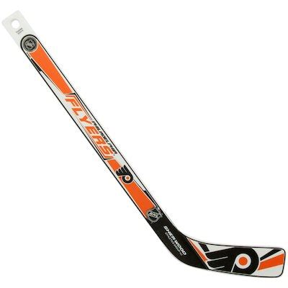
- Chicago Blackhawks $85.00 each
Saturday, November 10, 2018 1PM Section 121

- Detroit Red Wings $80.00 each
Tuesday, December 18, 2018 7PM Section 121

- Calgary Flames $105.00
Saturday, January 5, 2019 1PM Section 121

- Boston Bruins $100.00 each
Wednesday, January 16, 2019 7:30PM Section 121

- Pittsburg Penguins $120.00 each
Monday, February 11, 2019 7PM Section 121

- Washington Capitals $120.00 each
Thursday, March 14, 2019 7PM Section 121

- Toronto Maple Leafs $100.00 each
Wednesday, March 27, 2019 7PM Section 118

WE ALSO HAVE 4 SEASON TICKETS
TO EACH HOME GAME

Section 117, Row 22, Seat #’s 3, 4, 5 & 6
Must purchase 2 or 4 tickets $184.00 each pair

3601 S. Broad Street
Philadelphia, PA 19148

