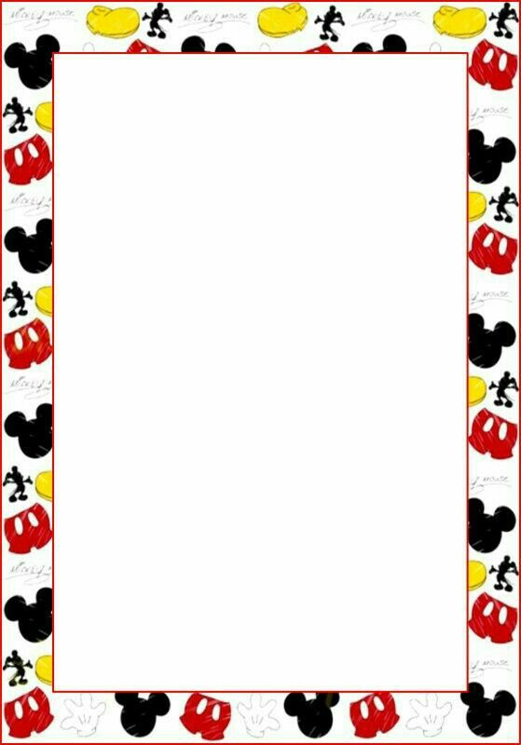
T

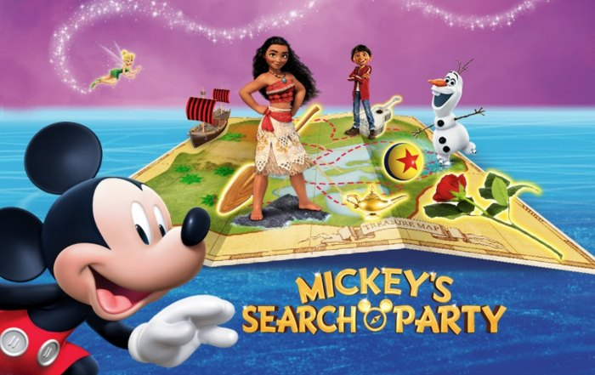

Tickets available at Cooper Solutions Center
1 Cooper Plaza, P132, Camden, NJ 08103
Phone (856) 968-8820 Fax (856) 968-8835

TWO DATES AVAILABLE
Friday, December 28, 2018 7:00PM
Saturday, December 29, 2018
11:00AM or 3:00PM

Club Box $54.00 each
Lower Level $51.00 each

Wells Fargo Center
3601 South Broad Street
Philadelphia, PA 19148

