Purchase your tickets @
Cooper Solutions Center’s two locations:
Main Office: One Cooper Plaza, Camden,
NJ 08103, Phone: (856) 968-8820

Satellite Office: CCBO, 1 Federal Street, 1st Floor,
Camden, NJ 08103, Phone: (856) 356-4826

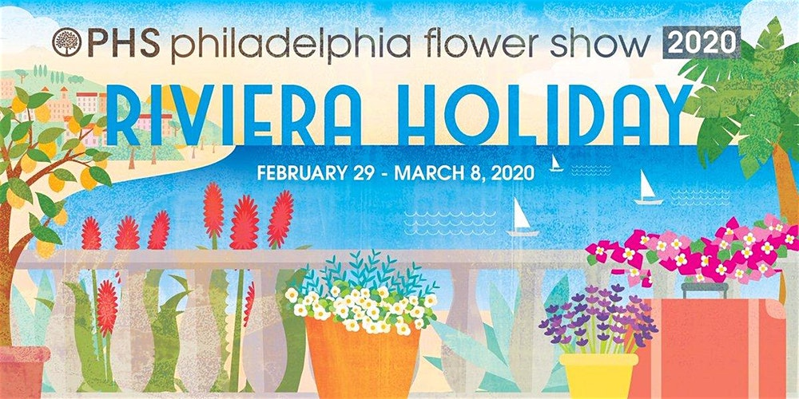
Adult $33.00 Youth $21.00 Child $16.00
(ages 30-105) (ages 18-29) (ages 5-17)

Pennsylvania Convention Center
12th and Arch Streets
Philadelphia, PA 19107

