Purchase your tickets @ Cooper Solutions Center’s two locations:

Main Office: One Cooper Plaza, Camden,
NJ 08103, Phone: (856) 968-8820

Satellite Office: CCBO, 1 Federal Street, 1st Floor,
Camden, NJ 08103, Phone: (856) 356-4826

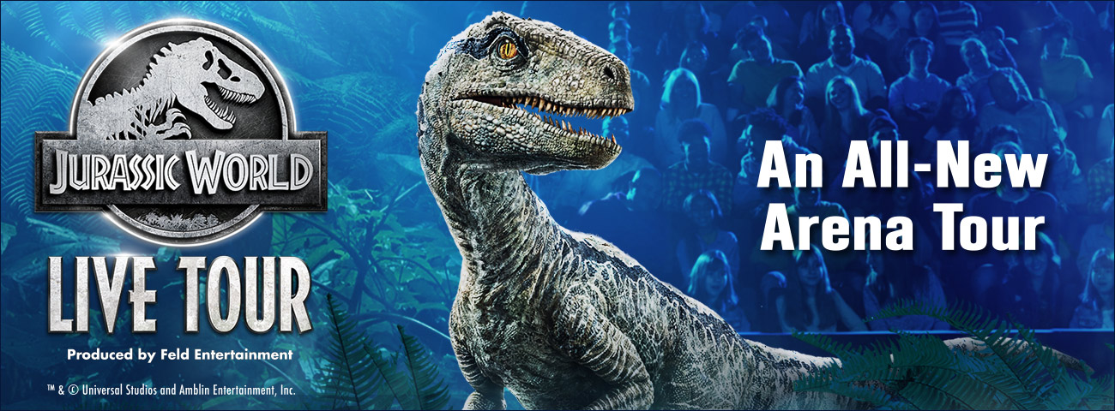
Jurassic World comes to life for the first time in a touring arena show!
Your trip to Isla Nublar takes a turn after the Indominus Rex escapes
and causes chaos in the park! The adventure continues as you
join forces with a team of scientists to save Jeanie, an all-new dinosaur.
Along the way, experience some of Jurassic World’s most iconic
dinosaurs including Blue the Raptor, Triceratops, Pteranodons and
the mighty Tyrannosaurus Rex!

Sunday, February 16, 2020 @ 12:00PM
Lower Level Seats - $58.00 each
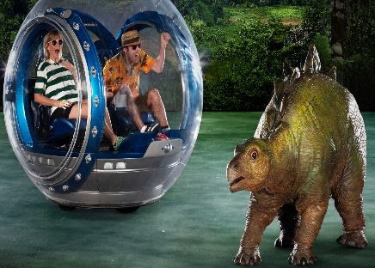
Limit of 4 Tickets

3601 S. Broad Street
Philadelphia, PA 19148

