Navex Global will update PolicyTech on Tuesday, November 13, 2018
Redesigned User Finder
This update applies to users with Document Owner privileges in the Cooper Policy Network (CPN). When setting up a document in the Properties Wizard, selecting users will be a cleaner and simpler experience.
BEFORE UPDATE:
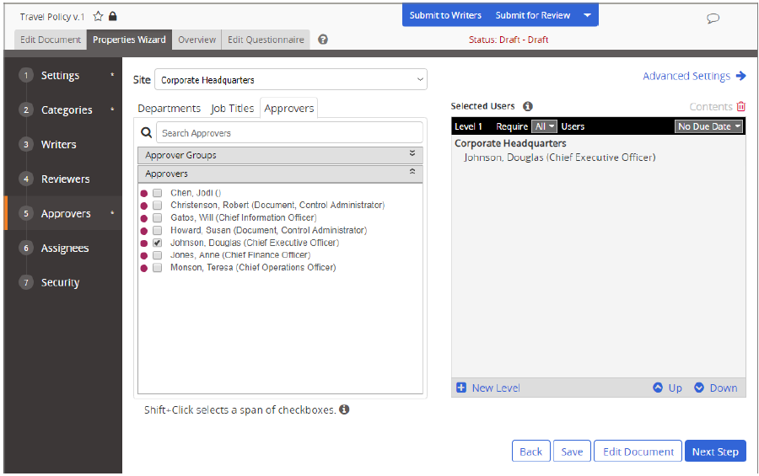
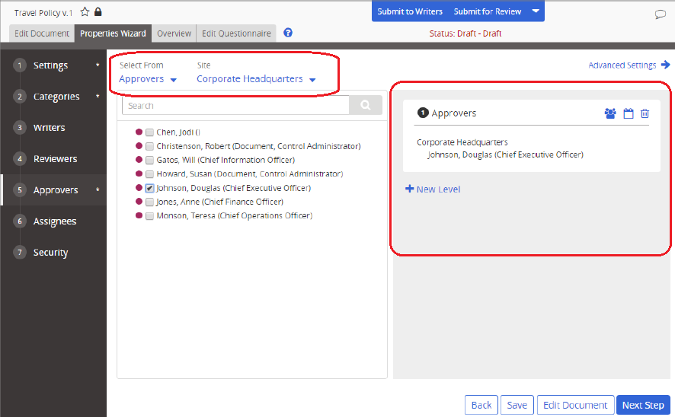
AFTER UPDATE:

Changes:
- Entity Selection: You will choose the type of entity you want to select from by clicking the Select From menu and then selecting from the list.
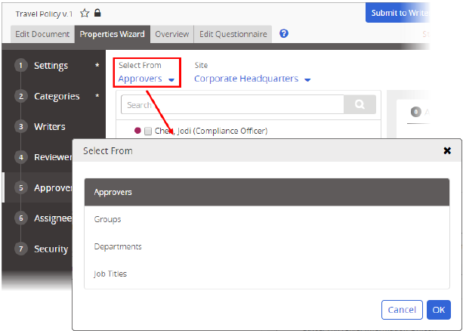
- Search Multiple Sites: You can make multiple site selections and search all those sites at once. Cooper mainly utilizes the CUHC site for policies and procedures.
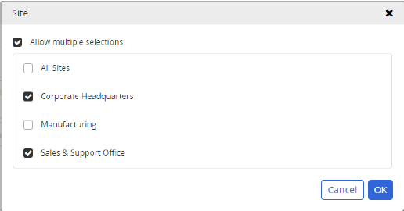
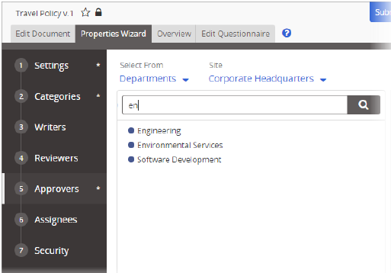
- Search for Departments, Groups, or Job Titles: Previously, searching applied only to individual users. You can now search for other entities as well.

- User Selection Count: The total number of individual users selected is now displayed.
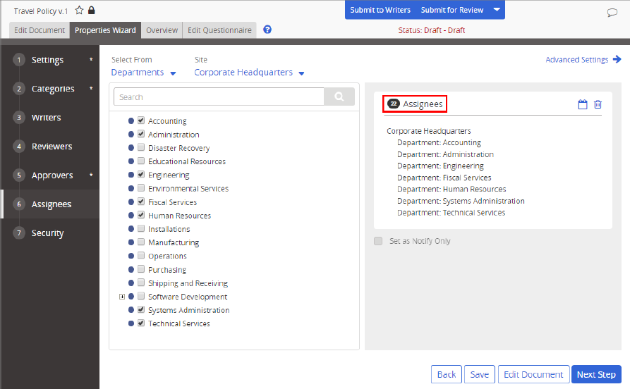
- Rearrange Users in Levels: When using levels, you can now drag user names from one level to another.
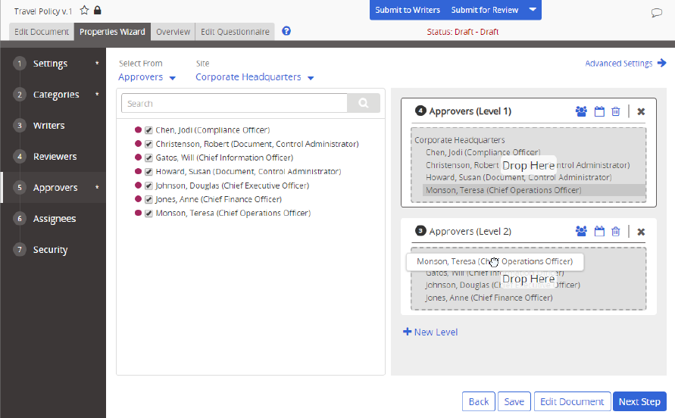
- Other Changes:
  - If a level is empty, you can now click X to remove the level immediately (instead of waiting for the page to reload).
  - Job title groups are now included within the Groups option instead of being separately listed.
  - The ability to delete a selected entity by double-clicking it is no longer supported.

Questions? Contact Policy Administrator at cooperpolicynetwork@cooperhealth.edu

