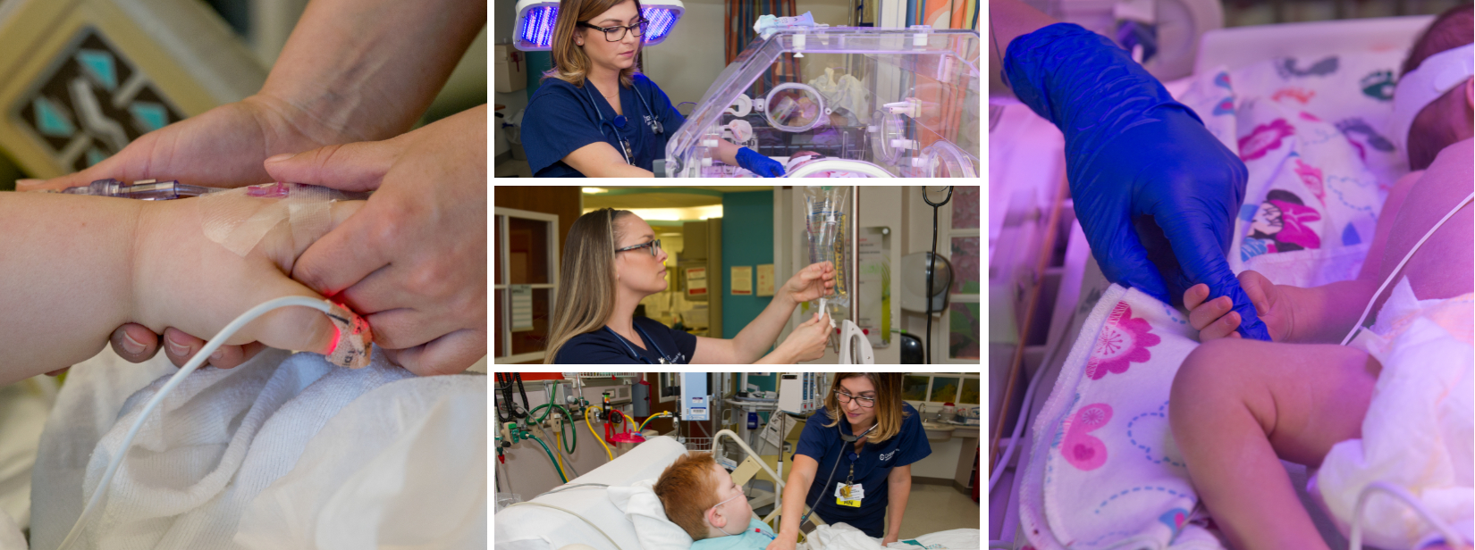
Cooper University Health Care is not just another health care employer. We are a world-class organization with resources, expertise and innovation that cannot be found anywhere else in Southern New Jersey. From MD Anderson Cancer Center at Cooper to Cooper Medical School of Rowan University, our resources and clinical learning opportunities are among the best in the nation. If you are a talented clinical expert with a truly patient-focused outlook, learn more about what Cooper has to offer.
PICU REFERRAL BONUS PROGRAM
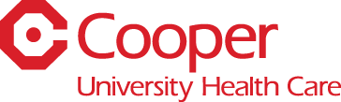
REFERRAL BONUS DETAILS

- $5000 for Full Time PICU RN Referral (Must have PICU Experience)
- $2500 for Part Time PICU RN Referral (Must have PICU Experience)

Referral Bonus Payout Structure: First half after 6 Months of Service, Second Half after 1 Year of Service
*Referral Bonus Program running from 11/20/18 to 1/30/19*
Note: To qualify for this referral bonus, the Current Employee’s name must be listed on referral’s official application through the Cooper Career Portal
Cooper University Health Care is an equal employment opportunity employer and does not discriminate on the basis of gender, race, age,
religion, disabilities, marital status, protected Veteran status, national origin, or any other category protected by federal or state law.

