Telehealth Staff Connect
TIGR Patient Education System STAFF JOB AID
Introducing Telehealth StaffConnect….

StaffConnect Features:

“My To-Do List” for prescribed patient specific education plan
- Bypass the phone – order and assign videos from the desktop or WOW
- Monitor the patient’s progress and prioritize teach back efforts
Step 1: Log in and open the Nurse Unit Dashboard  - From the Cooper Pulse page: click on Clinical Links and select Telehealth StaffConnect.  - Log into Telehealth | 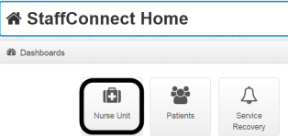  - Click on the Nurse Unit icon as shown in the screen shot to the left.  Note: StaffConnect is available from any Cooper Workstation or WOW
Step2: Locate the patient  - Select your unit from the dropdown box  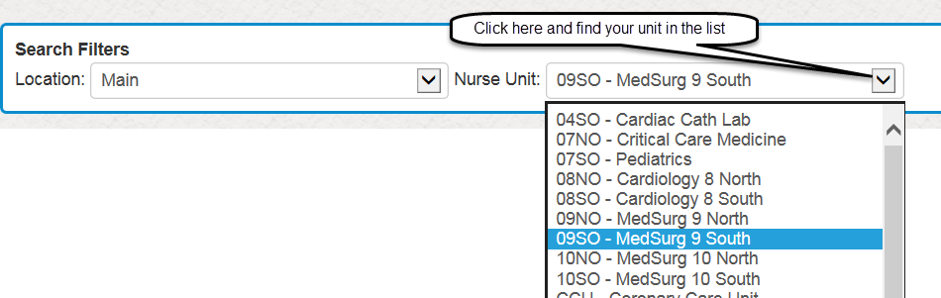 | - Locate your patient on the unit list  - Click on the blue button in the Actions column  - Select View Education Plan  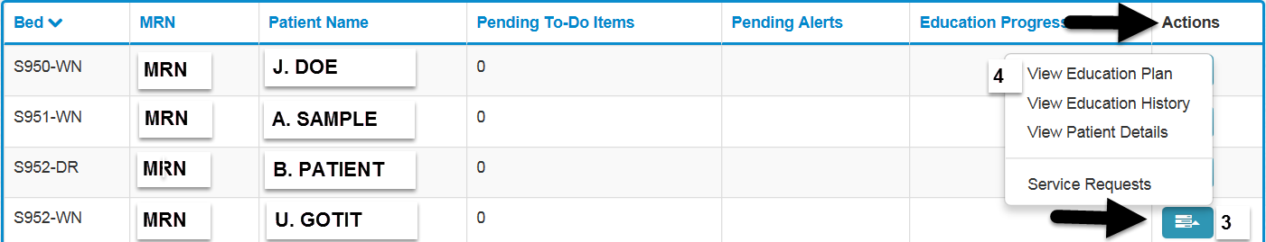
Step 3: View/Assign Education | - Click Assign New Items  - Click Assign Videos  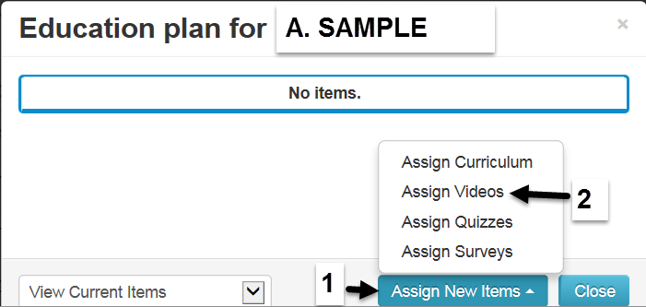
Step 4: Locate and Assign Videos  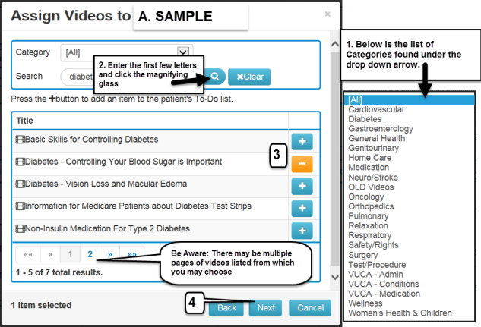 | - Use the Category option: Click on the drop down arrow and see the list of available video categories such as Cardiovascular, Diabetes, and Orthopedics etc.  OR  - Use the Search field to type in the first few letters of the video topic and then click the magnifying glass  - To assign a video click the plus sign. Once assigned the icon becomes a minus sign. ----Click the minus sign to remove if assigned in error  - Click the “Next” button to confirm the assignment. The system will present a list of assigned videos; click Next again to accept the assignment.  - The selected videos will now appear on the patient’s My To-Do List.
Step 5: Play/Start a video for the patient directly on their Television  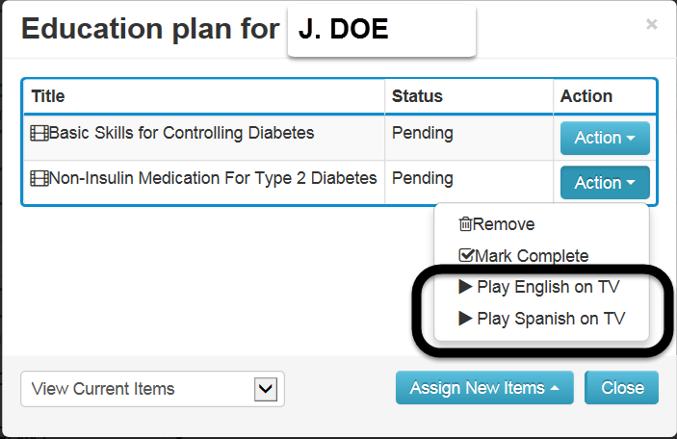 | - Click Action and select Play Video on TV  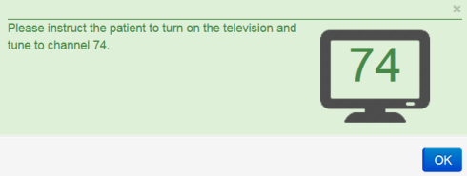  - The assigned TV Channel is displayed. (channels 73-83 are used for video viewing  - Turn the patient TV on and tune to the channel number provided  - The video will begin in approximately 90 seconds  Note: If starting the video at a time other than the initial assignment follow these steps: different encounter with the patient open telehealth> find the patient >click the action button>Click View Education plan>click blue button> Click Play English on TV or when available and applicable Play Spanish on TV> have the patient tune to the assigned channel)
Step 6: Demonstrate how to initiate a video themselves to the Patient  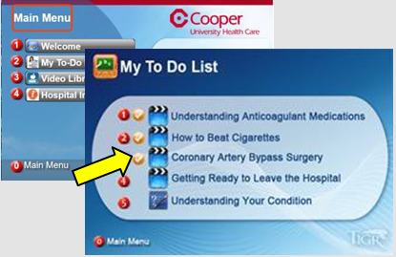 | - Advise the patient on their video education plan and how they can initiate watching a video by following these steps:  - Dial 1005981 from the bedside phone  - Select “1” for English, “2” for Spanish  - Select “2” to view menus & their “My To-Do List”  - Tune the TV as directed and press “#” for Menu  - Select “My To-Do List” and view their video

Note: Once a video has been watched, a check mark will appear for that video on the Patient My To Do list to help you and the patient know what they have already viewed. Progress can also be viewed by the nurse in Telehealth StaffConnect.
This allows the nurse to know when to talk to the patient about the educational videos they have viewed so that the education can be documented as a complete or needing re-enforcement in Epic.

