PHILADELPHIA FLYERS GAME TICKETS AVAILABLE AT COOPER SOLUTIONS CENTER
Phone (856)968-8820 Fax: (856)968-8835
One Cooper Plaza, P132
Camden, NJ 08103

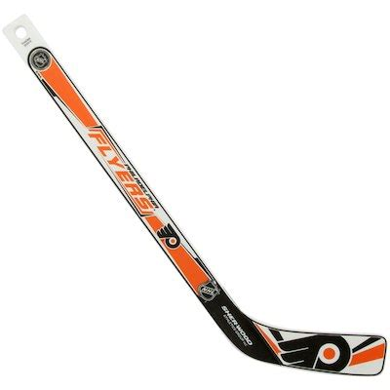

Toronto Maple Leafs $100.00 each
Wednesday, March 27, 2019 7PM
Section 118

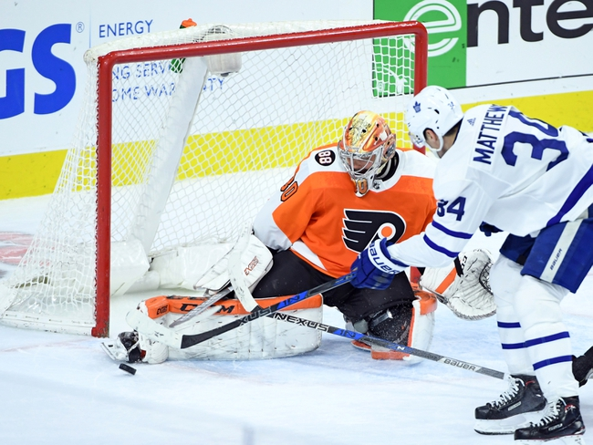

ONLY 4 TICKETS LEFT

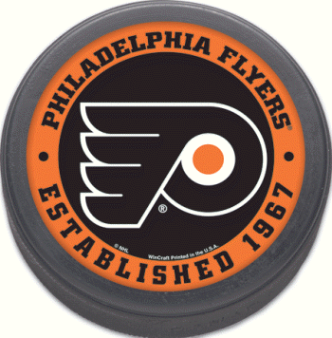
Wells Fargo Center
3601 South Broad Street
Philadelphia, PA 19148

