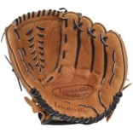
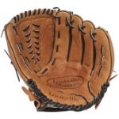
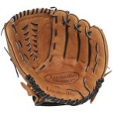
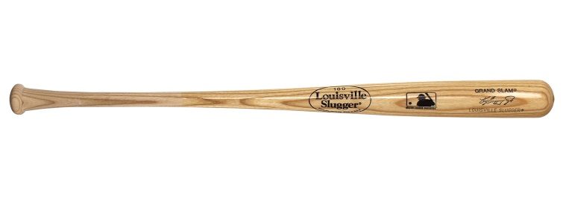
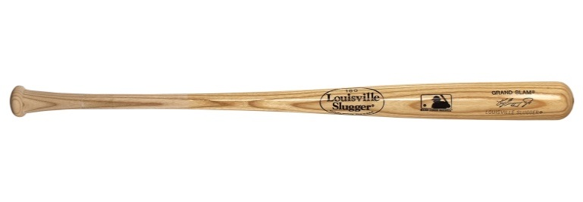
Purchase your tickets @
Cooper Solutions Center’s two locations:

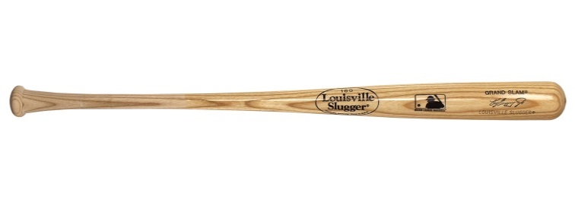
Main Office: One Cooper Plaza, Camden, NJ 08103, Phone: (856) 968-8820
Satellite Office: CCBO, 1 Federal Street, 1st Floor, Camden, NJ 08103
Phone: (856) 356-4826

- Phillies vs. Milwaukee Brewers on Tuesday, 5/14/19 at 7:05PM $34.00 each
- Phillies vs. Cincinnati Reds on Sunday, 6/9/19 at 1:05PM $39.00 each
- Phillies vs. Miami Marlins on Friday, 6/21/19 at 7:05PM $43.00 each
- Phillies vs. Washington Nationals on Saturday, 7/13/19 at 7:15PM $39.00 each
- Phillies vs. Atlanta Braves on Saturday, 7/27/19 at 7:05PM $34.00 each
- Phillies vs. Chicago White Sox on Sunday, 8/4/19 at 1:05PM $34.00 each
- Phillies vs. San Diego Padres on Sunday, 8/18/19 at 1:05PM $34.00 each
- Phillies vs. New York Mets on Sunday, 9/1/19 at 1:05PM $34.00 each
9. Phillies vs. Atlanta Braves on Monday, 9/9/19 at 7:05PM $34.00 each
