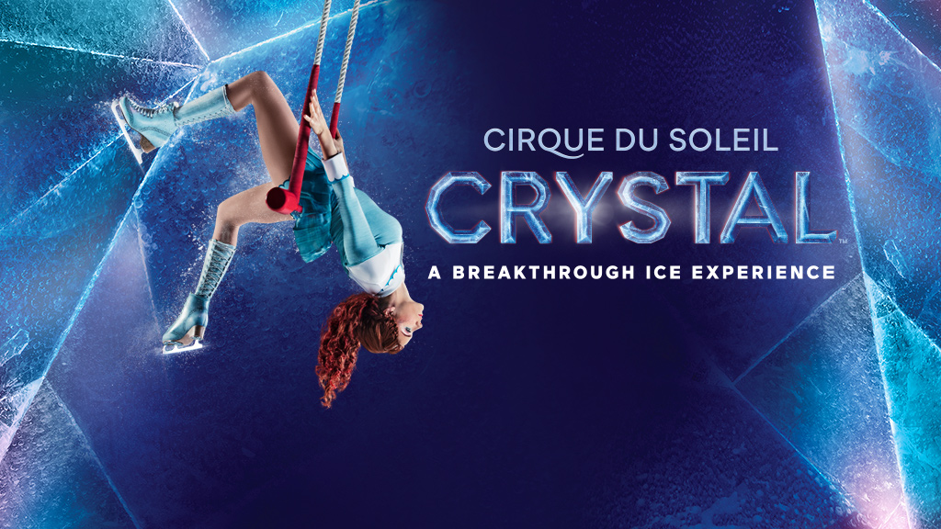

**Purchase your tickets @**

**Cooper Solutions Center’s two locations:**

Main Office

One Cooper Plaza

Camden, NJ 08103

Phone: (856) 968-8820

Satellite Office

CCBO, 1 Federal Street, 1st Floor

Camden, NJ 08103

Phone: (856) 356-4826

**Saturday, June 22, 2019 @ 4:00PM**

Wells Fargo Center

3601 South Broad Street

Philadelphia, PA 19148

Club Box Seats $52.00 each