Purchase your tickets @
Cooper Solutions Center’s two locations:

Main Office: One Cooper Plaza, Camden
Phone: (856) 968-8820

Satellite Office: CCBO, 1 Federal Street,
1st Floor, Camden Phone: (856) 356-4826
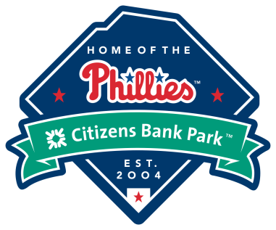

TICKETS AVAILABLE FOR:
Monday, August 26, 2019
7:05 PM Section 208
$35.00 each

Click link below for payroll deduction form:
http://portal/Departments/Errand%20Solutions/Document%20Library/Cooper%20Payroll%20Deduction%20Form.pdf

