Purchase your tickets @
Cooper Solutions Center’s two locations:
Main Office: One Cooper Plaza, Camden,
NJ 08103, Phone: (856) 968-8820
Satellite Office: CCBO, 1 Federal Street, 1st Floor,
Camden, NJ 08103, Phone: (856) 356-4826

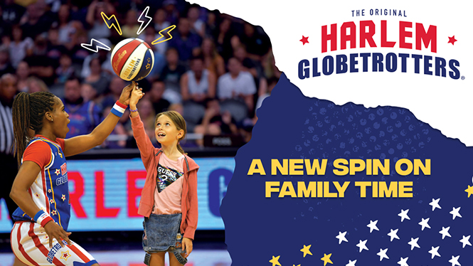
Sunday, March 1, 2020, 12PM
Lower Level Seats (section 101) $55.00 each
3601 South Broad street
Philadelphia, PA 19148

