Purchase your tickets @
Cooper Solutions Center’s two locations:
Main Office: One Cooper Plaza, Camden, NJ, Phone: (856) 968-8820
Satellite Office: CCBO, 1 Federal Street, 1st Floor, Camden, NJ, Phone: (856) 356-4826
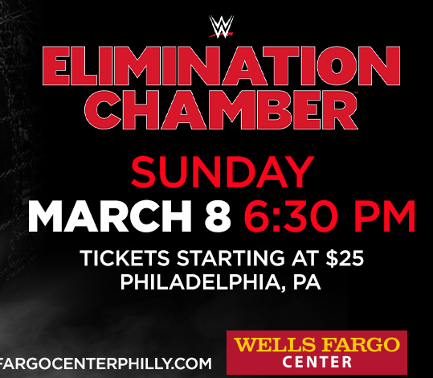
3601 South Broad St., Philadelphia, PA 19148
Club Box 4 Tickets are $79.00 each
Club Box 24 Tickets are $129.00 each

