**Discount available at:**

**St. Anthony of Padua School,**

**2824 River Road, Camden, NJ 08105**

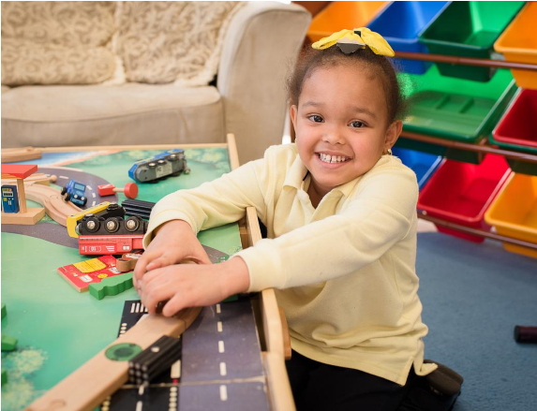

**ARE YOU LOOKING FOR A DUAL-**

**LANGUAGE PRE-K PROGRAM FOR**

**YOUR CHILD?**

**5**

**0**

**% of daily**

**instruction in**

**English and**

**% in Spanish**

**50**

**AGES 2 1/2 - 5**

**TUITION**

Children must be

potty trained

$100 a week -

vouchers accepted

**Art, Music,**

**Gym,**

**Computers,**

**STEM**

**CONTACT**

(856) 966-6791

mperez@cspschools.org

**VIRTUAL AND IN-PERSON SLOTS**

**AVAILABLE**

**Cooper University Health Care Employees receive a 10% discount**

Tuition assistance may be available (depending on household income) ))requirements)

**Must present your Cooper University Healthcare ID Badge to receive the discount**